

DESIGN STAGE 2 DRAFT SAMPLE EXAMINATION

Section 7 of the WACE Manual: 2008 Revised Edition outlines the policy on WACE examinations.

Further information about the WACE Examinations policy can be accessed from the Curriculum Council website at

The purpose for providing a sample examination is to provide teachers with an example of how the course will be examined. Further finetuning will be made to this sample in 2008 by the examination panel following consultation with teachers, measurement specialists and advice from the Assessment, Review and Moderation (ARM) panel.

2008/18734[v2]




Western Australian Certificate of Education, Draft Sample Examination
Question/Answer Booklet

Design
Please place your student identification label in this box
WRITTEN PAPER
STAGE 2

Student Number: In figures

In words

Time allowed for this paper
Reading time before commencing work: Ten minutes
Working time for paper: Two hours and thirty minutes

Materials required/recommended for this paper
To be provided by the supervisor
This Question/Answer Booklet

To be provided by the candidate
Standard items: Pens, pencils, eraser or correction fluid, ruler, highlighter
Special items: Two A3 sheets extracted from your examination portfolio (under review)

Important note to candidates
No other items may be taken into the examination room. It is your responsibility to ensure that you do not have any unauthorised notes or other items of a non-personal nature in the examination room. If you have any unauthorised material with you, hand it to the supervisor before reading any further.

Structure of this paper

Section | Suggested working time | Number of questions available | Number of questions to be attempted | Marks available
Section One:  Short response | 60 minutes | 40 | 10 | 40
Section Two:  Extended response | 90 minutes | 8 | 2 | 60
 |  |  | [Total marks] | 100

Instructions to candidates
- The rules for the conduct of Curriculum Council examinations are detailed in the Student Information Handbook. Sitting this examination implies that you agree to abide by these rules.

- For Section 1, you are to answer the questions in the space provided immediately after each question in this Question/Answer Booklet

- For Sections 2, write your answers in a separate Answer Booklet. A blue or black ballpoint or ink pen should be used.

- Spare answer pages may be found at the end of this booklet. If you need to use them, indicate in the original answer space where the answer is continued (i.e. give the page number).

SECTION ONE—SHORT ANSWER

In this section there are FORTY (40) questions, one for each of the FOUR (4) contexts.
SELECT ONE CONTEXT ONLY. Answer all questions in that context.

Suggested writing time 60 minutes [40 marks].

Structure of this section

 | Context | Question numbers | Pages | Number of questions to be attempted | Marks available
1 | Photography | 1–10 | 1–11 | 10 | 40
2 | Graphic | 11–20 | 12–16 | 10 | 40
3 | Technical Graphics | 21–30 | 17–22 | 10 | 40
4 | Dimensional | 31–40 | 23–28 | 10 | 40

CONTEXT 1: PHOTOGRAPHY

Question 1
Identify four ways in which a photographer could build a profile of a target audience.
[4 marks]

Question 2
Explain how social and cultural changes over time can affect the way in which food is photographed.
[4 marks]

CONTEXT 1: PHOTOGRAPHY

Question 3
In advertising photography, outline THREE considerations for a successful advertisement.
[3 marks]

Question 4
List five communication environments.
[5 marks]

Question 5
Outline two technological developments that have influenced photographic practice.
[5 marks]

CONTEXT 1: PHOTOGRAPHY

Question 6
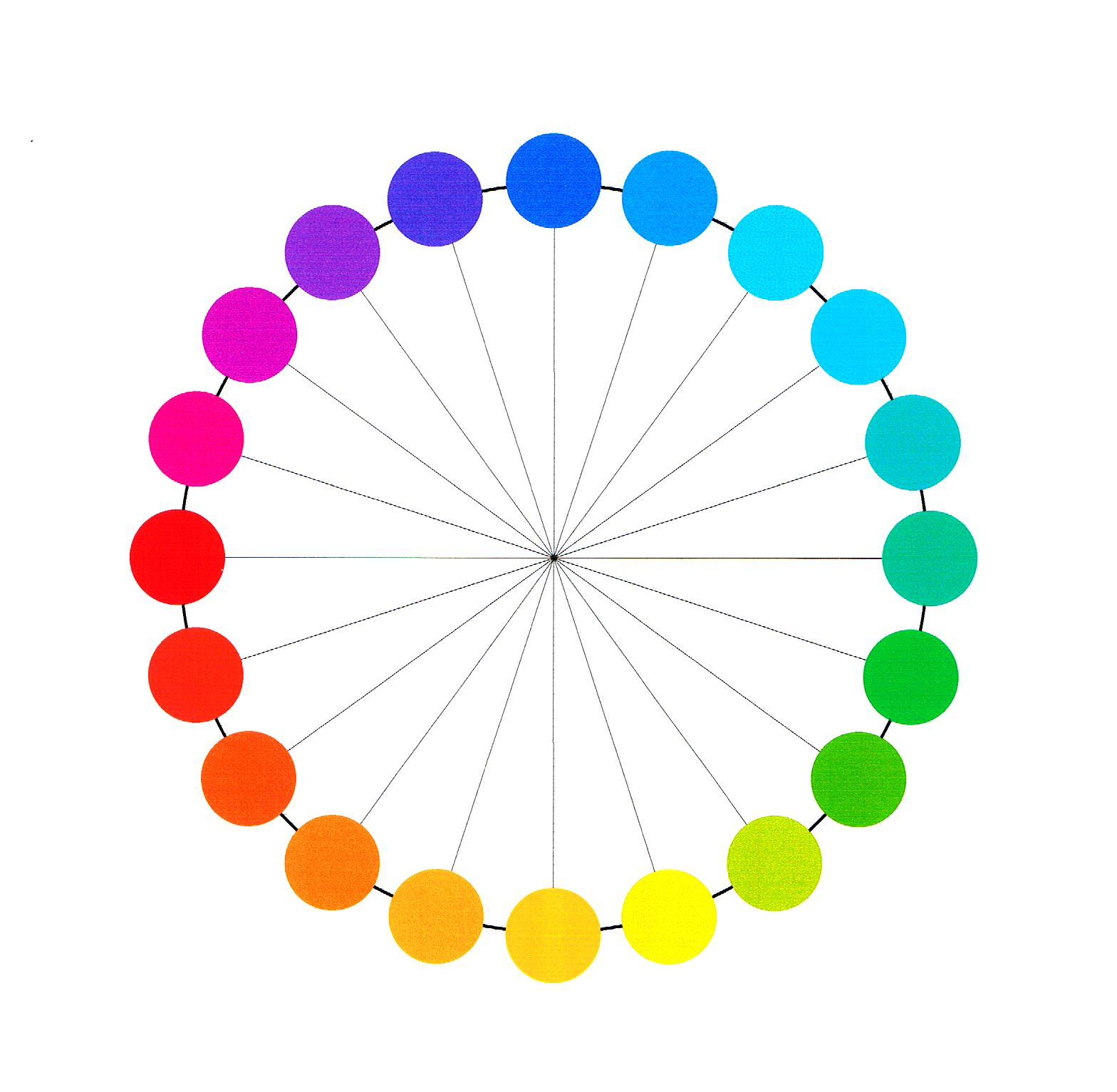
[From: P. Green-Armytage]
Look at the colours on the colour wheel ABOVE and answer the following:

- Choose any pair of complementary colours. Explain how they could be used to create an effect.
[2 marks]
Colours chosen: and

CONTEXT 1: PHOTOGRAPHY

- Give two examples of warm colours. Explain how they could be used to create a specific atmosphere or effect.
[2 marks]

Question 7
Explain the meaning of each of the following in terms of colour: hue, tone, saturation
[3 marks]

Question 8
Select Hue, Tone or Saturation and describe an example of its application.
[3 marks]

CONTEXT 1: PHOTOGRAPHY

Question 9
In the case of four identical photographs of a person what colours could you use, in the background, or in toning the image, to create an emotional response in the viewer? Give four examples of colours you could use and describe the feelings or emotions they could suggest.
[5 marks]

CONTEXT 1: PHOTOGRAPHY

Question 10
Explain two aspects of a communication model that can be applied to help read or construct a message.
[4 marks]

THIS SPACE HAS BEEN LEFT BLANK INTENTIONALLY

SECTION ONE—SHORTANSWER
CONTEXT 2: GRAPHIC

Question 11
A shoe manufacturer has asked you to design a magazine advertisement for a new children’s’ shoe. The advertisement must attract the target audience. Identify 6 areas of focus to consider when designing this advertisement.
[6 marks]

Question 12
You have found an image in a book which you would like to use as part of an article you are writing for a daily newspaper. What steps would you need to take to be able to do so legally?
[3 marks]

CONTEXT 2: GRAPHIC

Question 13
Briefly list five of the design elements and principles used in the design of the Australian flag.
[5 marks]

For copyright reasons this image cannot be reproduced in the online version of this document but may be viewed at http://www.australiaday.gov.au/pages/page22.asp
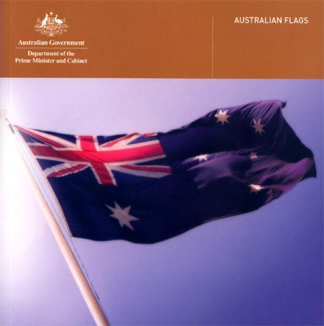
From: Department of Prime Minister and Cabinet, 1998

CONTEXT 2: GRAPHIC

Question 14
Identify the values, beliefs and attitudes the designer of the Australian flag wished to portray.
[5 marks]

Question 15
A major graphic design publication has decided to discontinue their print publication and go completely on-line. Identify advantages and/or disadvantages this change could bring.
[4 marks]

CONTEXT 2: GRAPHIC

Question 16
List four environmental considerations which should be thought about when designing packaging.
[4 marks]

Question 17
In design work there are many areas of specialisation. List three of them, giving a short description of the job, and how each fits into the work place.
[3 marks]

Question 18
A bus timetable leaflet showing times and routes, to assist various cultural groups, is being produced by the council for distribution to local homes. Briefly list 3 cultural groups of people that this leaflet may have to cater for. Briefly identify problems each group might face when using the leaflet. Outline ways in which the design could help overcome these problems.
[3 marks]

CONTEXT 2: Graphic

Question 19
Explain the meaning of the statement ‘form follows function’ and give an example of how it can be used in design.
[3 marks]

Question 20
Below is a list of things that could be considered when designing a leaflet for the provision of handicapped services to local council residents: These include the partially sighted and those with physical and intellectual disabilities.

THE PRINCIPLES OF UNIVERSAL DESIGN

UNIVERSAL DESIGN:
PRINCIPLE THREE: Simple and Intuitive Use
Use of the design is easy to understand, regardless of the user's experience, knowledge, language skills, or current concentration level.
Guidelines:
3a. Eliminate unnecessary complexity.
3b. Be consistent with user expectations and intuition.
3c. Accommodate a wide range of literacy and language skills.
3d. Arrange information consistent with its importance.
3e. Provide effective prompting and feedback during and after task completion.
List FOUR ways that this principle could be addressed in a leaflet design.
[4 marks]

SECTION ONE—SHORT RESPONSE
CONTEXT 3: TECHNICAL GRAPHICS

Question 21
Name TWO types of communication and give examples to illustrate when a designer would use each type.
[2 marks]

Question 22
Name four important economic factors to be considered when designing a product.
[2 marks]

Question 23
A client has asked you to develop a major design project intended to get a response from a targeted audience.
- Identify an audience
- Describe what methods you would use to get a response
- justify the use of these theories to your client
[6 marks]

Question 24
List THREE techniques that could be used to determine the needs and wants of a client before the design stage of a project commences.
[2 marks]

CONTEXT 3: TECHNICAL GRAPHICS

Question 25
Choose ONE of the following graphics styles or methods:
measured perspective, floor plans, technical drawings, typographic design, sketching or any other that you are familiar with.
- Explain two applications of the graphics style or method in industry and society.
- Explain who would create these graphics types.
- Explain why and how these particular graphics types are used. Identify the end users.
[6 marks]

THIS SPACE HAS BEEN LEFT BLANK INTENTIONALLY

Question 26
Below is a list of guidelines that could be considered when creating a proposal for the provision of handicapped services to local council residents: These include the partially sighted and those with physical and intellectual disabilities. The services could include a design for an accessible seating area, a small shelter, a park with walking paths, a garden, a meeting hall, or some other service.

THE PRINCIPLES OF UNIVERSAL DESIGN

UNIVERSAL DESIGN:
PRINCIPLE FIVE: Tolerance for Error
The design minimizes hazards and the adverse consequences of accidental or unintended actions.
Guidelines:
5a. Arrange elements to minimize hazards and errors: most used elements, most accessible; hazardous elements eliminated, isolated, or shielded.
5b. Provide warnings of hazards and errors.
5c. Provide fail safe features.
5d. Discourage unconscious action in tasks that require vigilance.

List FOUR ways that this principle could be addressed in a leaflet design.
[4 marks]

CONTEXT 3: TECHNICAL GRAPHICS

Question 27
Identify the most important legal constraint to consider when publishing a document such as a plan.
[3 marks]

Question 28
Name THREE elements of a design that could have cultural significance. Give an example of the way that culture can be expressed in these elements.
[6 marks]

CONTEXT 3: TECHNICAL GRAPHICS

Question 29
Name three lifestyle preferences that could be considered when designing a sports oriented product and state briefly why they are relevant.
[3 marks]

Question 30
Select an advanced material e.g. a composite, a special alloy, a laminated material or other material that you may be familiar with.
- Give examples of where this material could be used.
- Describe its properties.
- Give advantages and/or disadvantages of its use.
[6 marks]

SECTION ONE—SHORT RESPONSE
CONTEXT 4: DIMENSIONAL

Question 31
Describe the properties of a recyclable material that you are familiar with and suggest design uses for it.
[2 marks]

Question 32
Choose ONE of the following graphics styles or methods:
measured perspective, floor plans, technical drawings, typographic design, sketching or any other that you are familiar with.
- Explain two applications of the graphics style or method in industry and society.
- Explain who would create these graphics types.
- Explain why and how these particular graphics types are used. Identify the end users.
[6 marks]

CONTEXT 4: DIMENSIONAL

Question 33
The following list could be considered when creating a proposal for the design of products or services for people with disabilities. These include the partially sighted and those with physical and Intellectual disabilities. The design could be for fashion items, murals, jewellery, ceramic ware or other designed objects.

THE PRINCIPLES OF UNIVERSAL DESIGN

UNIVERSAL DESIGN:
PRINCIPLE SIX: Low Physical Effort
The design can be used efficiently and comfortably and with a minimum of fatigue.
Guidelines:
6a. Allow user to maintain a neutral body position.
6b. Use reasonable operating forces.
6c. Minimize repetitive actions.
6d. Minimize sustained physical effort.
List FOUR ways that this principle could be addressed in a leaflet design.
[4 marks]

Question 34
List FOUR common issues for a designer to consider when designing a project
[4 marks]

CONTEXT 4: DIMENSIONAL

Question 35
[From: P. Green-Armytage]
Look at the colours on the colour wheel ABOVE and answer the following:

- Choose any two complementary colours. Explain how they could be used to create an effect.
[2 marks]
Colours chosen: and

CONTEXT 4: DIMENSIONAL

- Give two examples of warm colours. Explain how they could be used to create a specific atmosphere or effect.
[2 marks]

Question 36
Explain the meaning of each of the following in terms of colour: hue, tone, saturation
[3 marks]

Question 37
Select either hue, tone or saturation and describe an example of its application.
[3 marks]

CONTEXT 4: DIMENSIONAL

Question 38
Give four examples of values and beliefs that drive design practice. Briefly describe how they affect design
[8 marks]

Question 39
Describe what techniques can be used to determine the needs and wants of a client before starting the design stage of a project
[3 marks]

CONTEXT 4: DIMENSIONAL

Question 40
Identify the most important legal constraint to consider when publishing a design such as a plan, garment design, sketch proposal
[3 marks]

END OF SECTION ONE

SECTION TWO—EXTENDED ANSWER

SECTION TWO—PART A

In this section there is ONE (1) question. All candidates must attempt this question.

Suggested working time: 45 minutes [30 marks].

Structure of this section

Section | Suggested working time | Number of questions available | Number of questions to be attempted | Marks available
Section Two—Part A | 45 minutes | 1 | 1 | 30
Section Two—Part B | 45 minutes | 4 | 1 | 30
 |  |  | [Total marks] | 60

Question 41
Photographs, Graphic images, technical graphic and dimensional designs are usually intended to convey a message to the viewer. Communication theories and other established design principles are used to construct these messages.

You are to select one of the projects you carried out in this subject and analyse it using the following key points to organise your answer:
- Describe how the project has used particular design elements and principles to communicate.
- Identify and discuss relevant parts of communication theories demonstrated in your work
- Discuss the use of colour or other design elements to express meaning.
- Describe the target audience.
- Outline the social values dealt with in the project
- Discuss meanings or cultural messages conveyed in the design
[30 marks]

SECTION TWO—PART B

In this section there are FOUR (4) questions. Answer the ONE (1) question in your context.

Suggested working time: 45 minutes [30 marks].

CONTEXT 1: Photography

Question 42
You have been asked by a design company to produce an advertisement that attempts to subvert* messages of major producers whose practices are seen as unethical. Choose one scenario from the numbered list below:
  - Alcohol or tobacco companies who glamorise drinking or smoking without reference to potential harm.
  - Clothing companies that may employ third world labour or take part in unorthodox methods like those associated with the fur trade.
  - Beauty industry companies that promote an unhealthy obsession with being thin.
  - Companies that employ animal testing in the development of their products.

Write a description of how you would address these key points:
- the stages of the design process
- the background research plan required for this project
- target audience
- relevant design principles
- the social values, representations and culture in your design.

*subvert-to subvert a message is to change its meaning, to undermine the intention of the original message.
[30 marks]

CONTEXT 2: Graphic
Question 43
You have been asked by a design company to produce an advertisement that attempts to subvert* messages of major producers whose practices are seen as unethical. Choose one scenario from the numbered list below:
- Alcohol or tobacco companies who glamorise drinking or smoking without reference to potential harm.
- Clothing companies that may employ third world labour or take part in unorthodox methods like those associated with the fur trade.
- Beauty industry companies that promote an unhealthy obsession with being thin.
- Companies that employ animal testing in the development of their products.

Write a description of how you would address these key points:
- the stages of the design process
- the background research plan required for this project
- target audience
- relevant design principles
- the social values, representations and culture in your design.

*subvert-to subvert a message is to change its meaning, to undermine the intention of the original message.
[30 marks]

CONTEXT 3: Technical graphics

Question 44
Describe how you would gather information on measurement categories such as demographics and/or ergonomics (and/or any other measurement that you are familiar with) to create a profile of the user or users for a design project. You can refer to one of your previous projects for this. You will need to describe the factors that you are interested in, describe how you would gather this information and how you would apply it in a design project.
[30 marks]

CONTEXT 4: Dimensional

Question 45
Write a description of a design process in your chosen field of design that has a social use, for example the application of universal design.
- Describe the stages of the design process that you would typically apply in this context
- Outline the technical considerations
- Identify the uses for the design work
- Explain the considerations that need to be made regarding the users of the design
[30 marks]

ACKNOWLEDGEMENTS

SECTION ONE

CONTEXT 1: PHOTOGRAPHY

Question 6: Colour wheel by kind permission Paul Green-Armytage.

CONTEXT 2: GRAPHIC

Question 13: Department of Prime Minister and Cabinet. (1998). Australian flags (Cover). Retrieved July, 2007, from Australia Day website: http://www.australiaday.gov.au/pages/page22.asp.

CONTEXT 4: DIMENSIONAL

Question 35: Colour wheel by kind permission Paul Green-Armytage.
Published by the Curriculum Council of Western Australia
27 Walters Drive
OSBORNE PARK WA 6017

